Notes Criteria

- Obviously, the title of your pages will not be "Notes Example", but rather, the topic being discussed.
- Do not title your notes pages based on units but rather based on the topic of the notes.
- How you generate your notes are up to you, below are TWO examples.
- You must take notes in this class regardless of the source of the notes.
Sources of notes:
- Classroom lectures on concepts
- Classroom lectures on lab procedures
- Reading your book
- Watching a video (Khan Academy or YouTube)
- Make as many notes pages as you need to be organized.

Example Notes #1: Notes in Notability
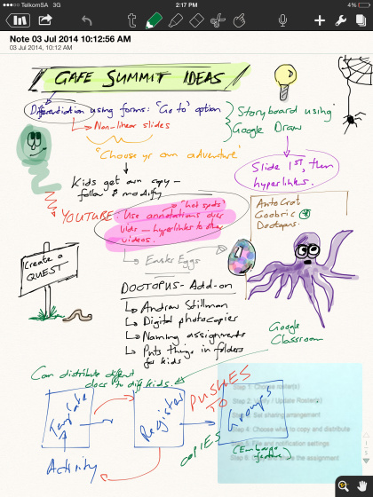

Example Notes #2: Notes done on paper
